Scholar Discussed How Consumption Played a Neglected Role in Creating National Identity in Britain’s White Settler Colonies
學者討論「英國性」如何透過消費行為在白人殖民地上滲透

The inaugural Annual Australian, Canadian, and Aotearoa New Zealand Studies Lecture in the Department of History, was given by Dr. Felicity Barnes of the University of Auckland and the lecture was entitled ‘“Buying Britishness”: Consumption and the construction of settler colonial identities in Australia, New Zealand, and Canada’. The lecture is the first in a series of three that will take place over the next few years. It is supported by the Institute of Creativity at HKBU.

In her lecture, Dr. Barnes argued that consumption played a neglected role in creating national identity in Britain’s white settler colonies. In particular, it was crucial to the formation of whiteness and the marginalization of Indigenous cultures. The lecture was attended by prominent guests from the Australian, Canadian, and New Zealand Consulates.

歷史系於5月30日舉辦講座，邀請紐西蘭奧克蘭大學Felicity Barnes博士演講，題為「購入英國性：消費行為與澳洲、新西蘭及加拿大定居者殖民身份認同的建立」。是次為澳洲、加拿大及新西蘭研究講座系列的第一講，獲浸會大學創意研究院撥款舉辦，並將於未來繼續舉行。

Felicity Barnes博士以兩次大戰之間的澳洲、加拿大及新西蘭為例，說明「英國性」如何透過消費行為在白人殖民地上滲透，以及原住民又如何被邊緣化。講座獲得澳洲、加拿大及新西蘭領事館的代表支持和出席。

Photo 1
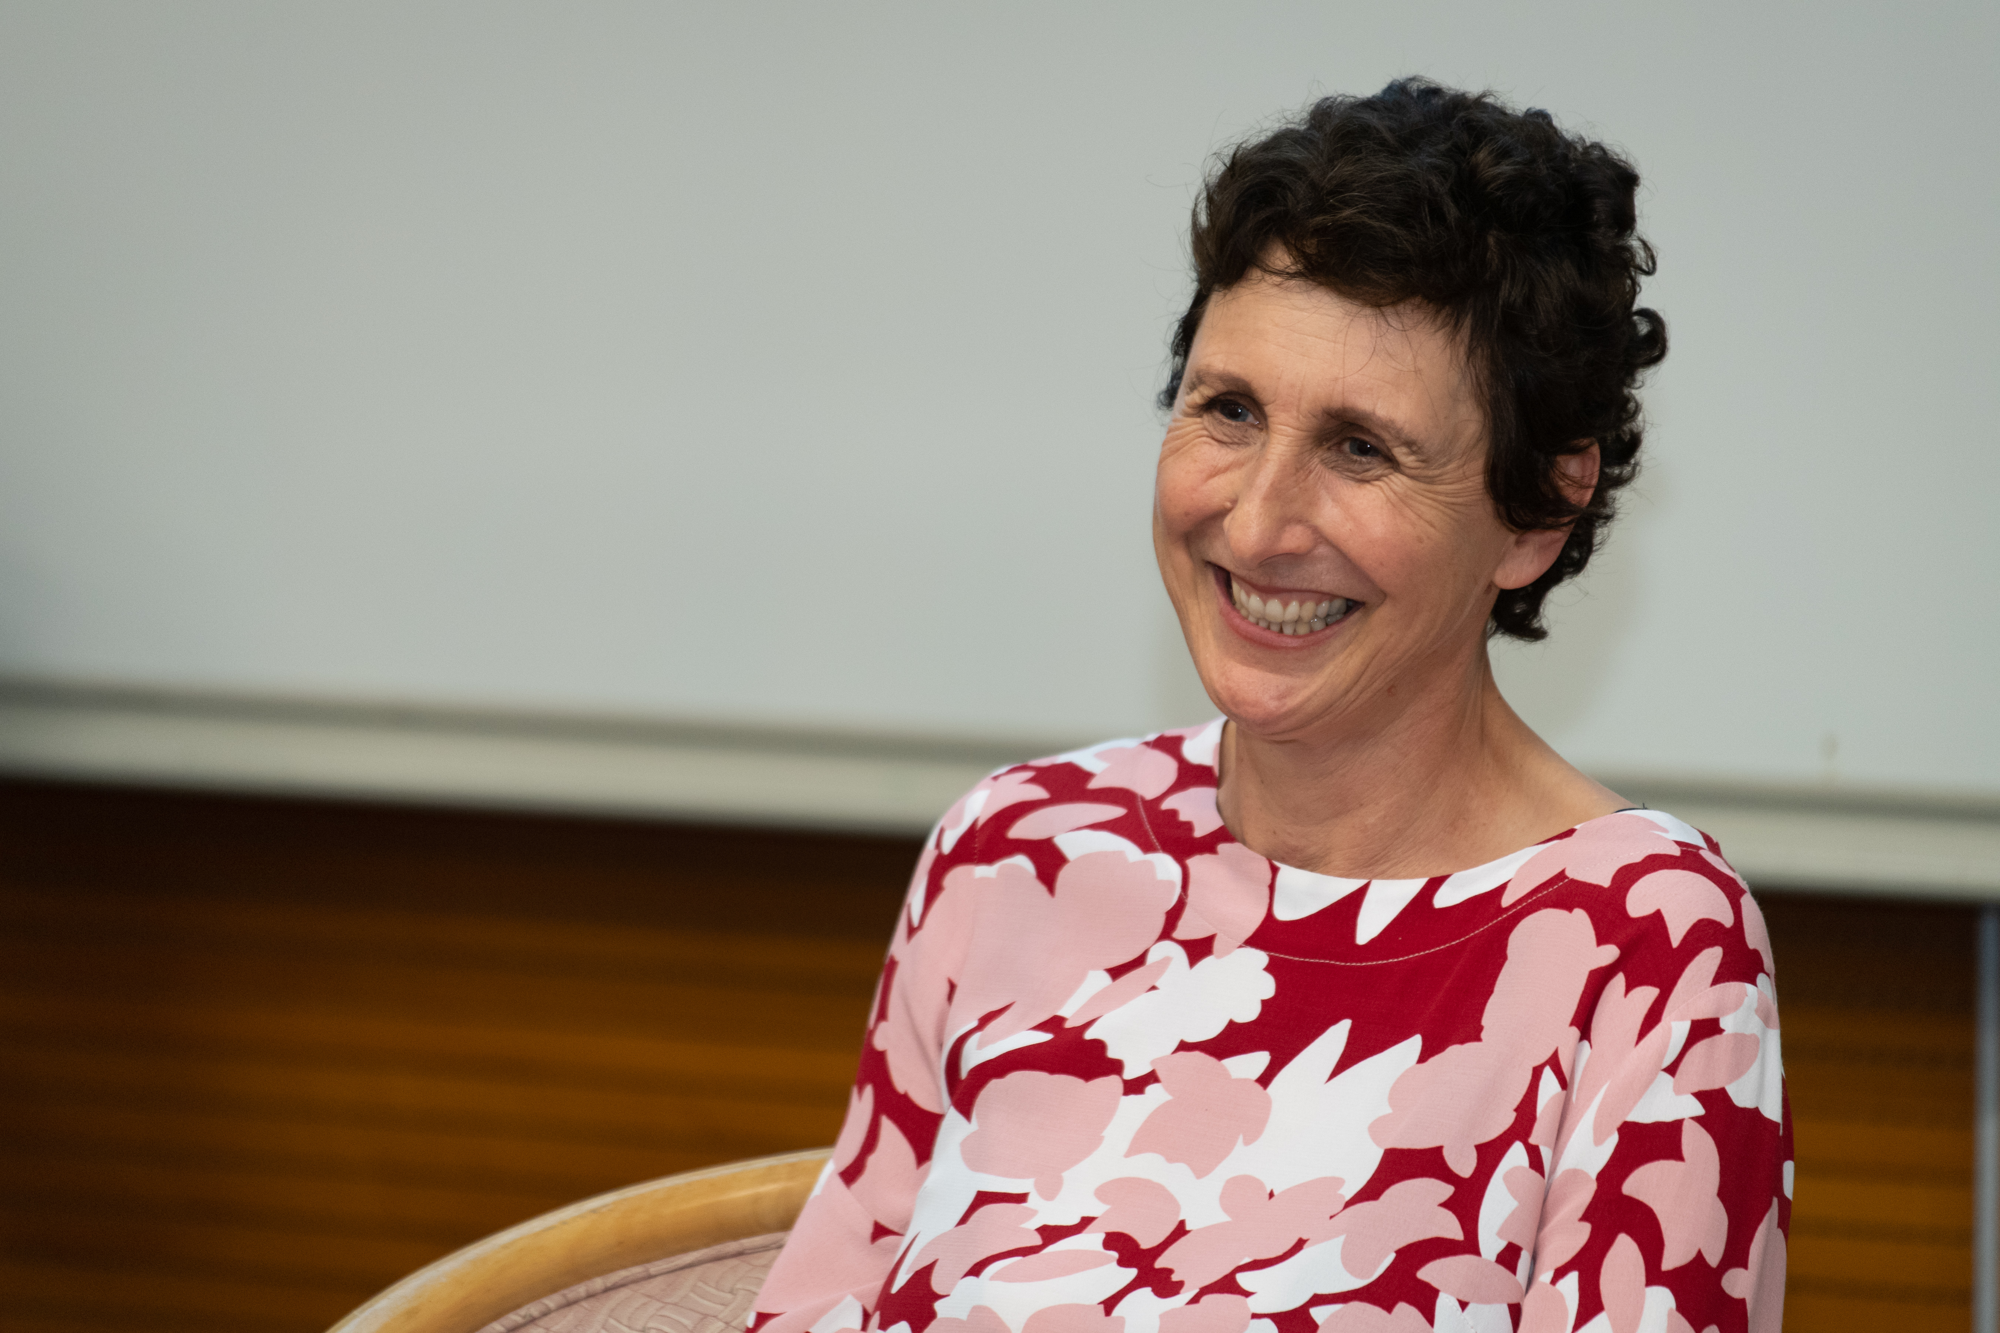
Dr. Felicity Barnes of the University of Auckland delivered a lecture entitled ‘“Buying Britishness”: Consumption and the construction of settler colonial identities in Australia, New Zealand, and Canada’.
紐西蘭奧克蘭大學Felicity Barnes博士演講，題為「購入英國性：消費行為與澳洲、新西蘭及加拿大定居者殖民身份認同的建立」。

Photo 2
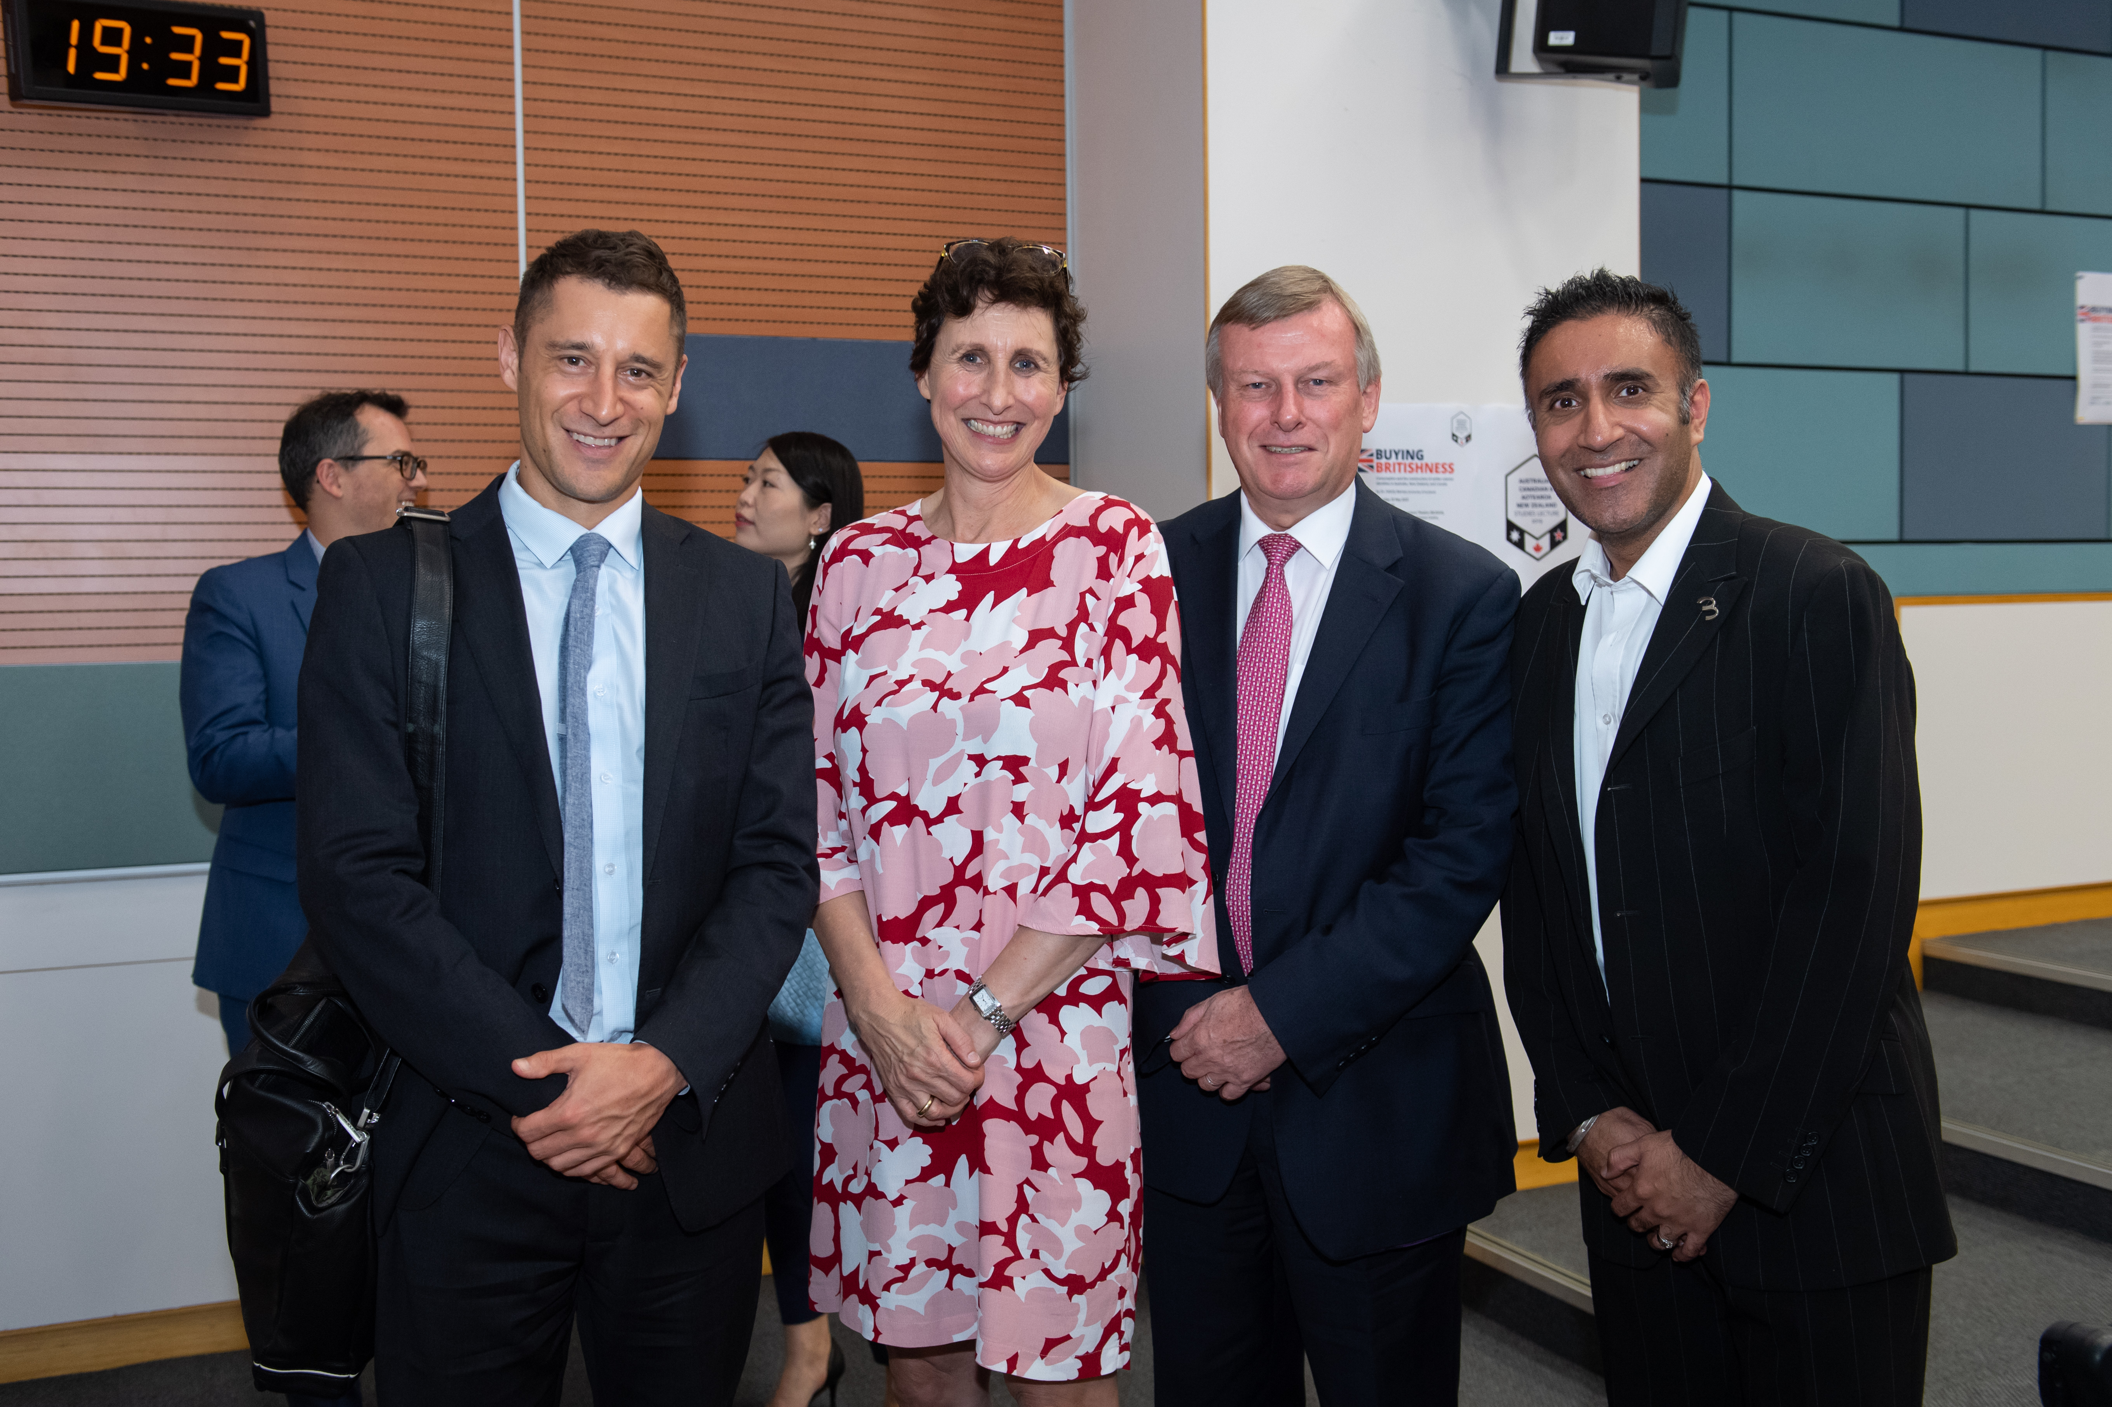

Contact person: Michelle Chan
Department: HIST
Number: 3411 7174/ michyychan@hkbu.edu.hk

