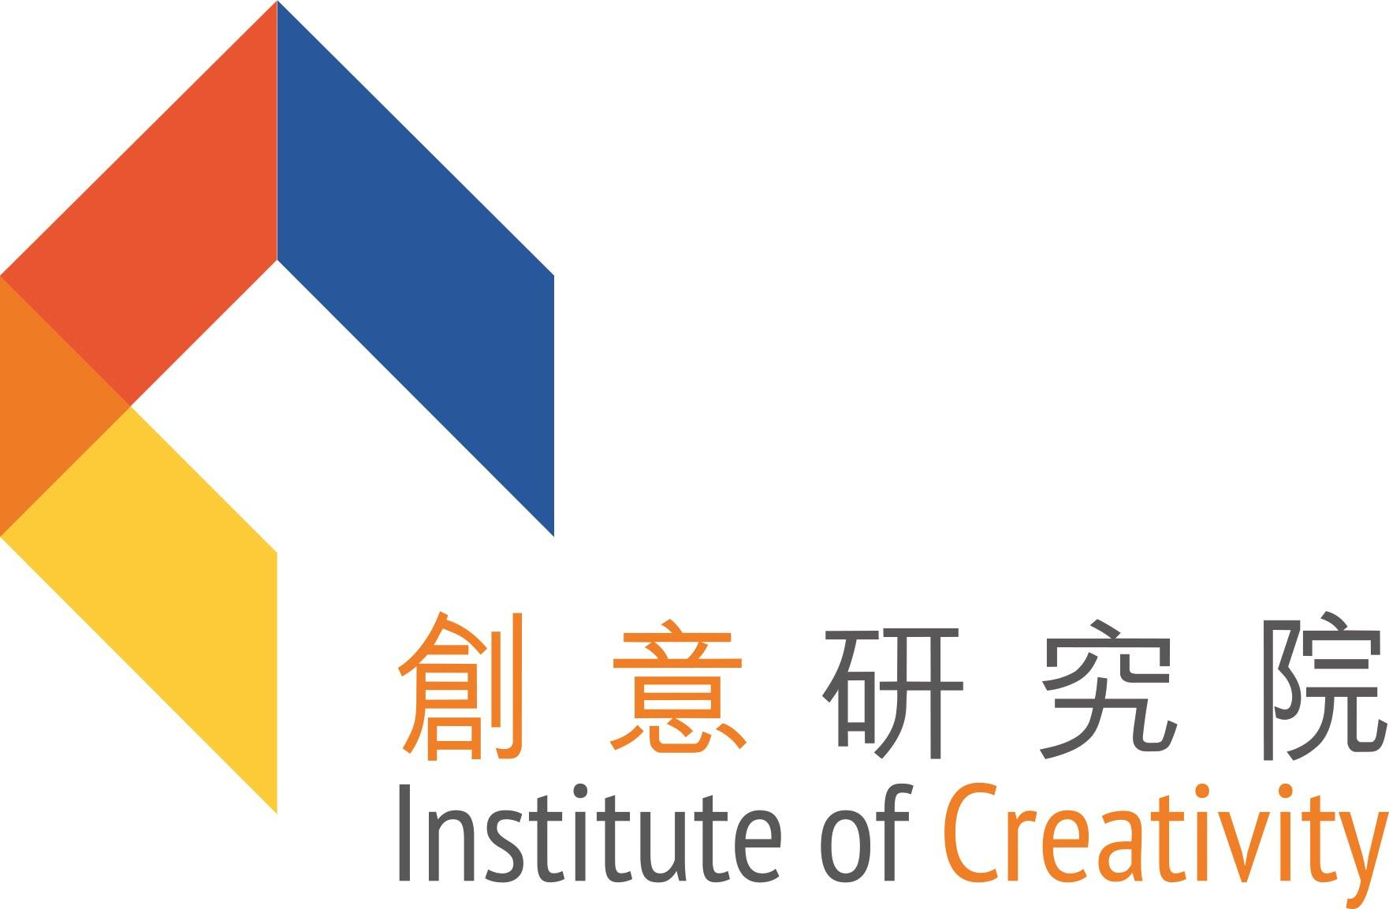

Application for Funding of IoC Events/Activities/Projects
(Normal Funding Limit: HK$100,000 or Below)

Background

The Institute of Creativity (IoC, http://ioc.hkbu.edu.hk/) was founded in March 2011 to offer a unique platform for international academic exchange by promoting interdisciplinary research and theme-based research, and supporting creative initiatives for the benefit of our community.

The University is grateful to the Hung Hin Shiu Charitable Foundation Limited for a donation of HK$100 million to set up the “Institute of Creativity – Dr. Hung Hin Shiu Development Fund”, in support of the operation, research development and academic exchange activities of the Institute.

Funding Proposal

Faculty/School/Academy can submit requests for funding of events/activities/projects (e.g., lectures, seminars, and workshops) in line with the Institute’s objectives, which emphasize some of the following: creativity; branding of HKBU; cross-disciplinarity; collaboration, both internally and externally on a global scale. In addition, the proposed events/activities/projects shall be related to certain focused areas of the University Interdisciplinary Clusters (i.e., Creative Media/Practice, Health and Drug Discovery, and Data Analytics and Artificial Intelligence in X), and/or Faculty/School/Academy Niche Research Areas.

Proposals may be submitted at any time. IoC funding is normally limited to HK$100,000 for each event/activity/project. Exceptionally, larger requests will be considered if suitably justified.

IoC funding is aimed at supporting innovative and creative activities. It may complement, but not duplicate, funding through other HKBU-wide schemes, e.g. the Strategic Development Fund. In particular, IoC funds may serve as matching funds for other schemes, in which case approval of such other funding must precede submission to IoC. It does not support regular conferences and research projects. Use of IoC funds must comply with all applicable HKBU regulations and will be monitored by the Finance Office.

Application Procedure

Interested parties are required to fill in an Application Form (Annex 1), and the speakers’ consent form (Annex 2, after the approval of the proposal). The Application Form should be submitted at least two months prior to the commencement of the event/activity/project to ioc@hkbu.edu.hk. Enquiry: 3411 7502.

Post-Completion Report

The applicant is required to submit a final report in CHINESE* with a summary in English in word version, within two months upon completion of the event/activity/project.

*An annual report in Chinese summarizing all IoC activities during the year has to be submitted to the Hung Hin Shiu Charitable Foundation Limited by the end of each calendar year.

This report should include the following:
- Objectives
- Introduction of the speaker(s)/partner institution(s) (if any)
- Details of the event/activity/project, e.g. content of talk(s), impact (about 300 Chinese characters per speaker or activity)
- Attendance (number and categories e.g. staff, students, visitors etc.)
- Soft copies of the promotional materials, e.g. posters, banners, invitation cards etc (the sponsorship and IoC logo must be clearly visible) in JPEG version
- Soft copies of event/activity/project photos and video clips of the event/activity/project for updating on the IoC website
- Selection of 2-3 photos per speaker or activity for IoC annual report
- Expenses summary
- An annual progress report is required if the event/activity/project lasts for more than one year

All reports should be sent to ioc@hkbu.edu.hk. Enquiry: 3411 7502.

Acknowledgement

All IoC-sponsored events/activities/projects are required to acknowledge the IoC funding support by including the following in ALL promotional materials:

- Sponsorship

Sponsored by Hung Hin Shiu Charitable Foundation
孔憲紹慈善基金贊助

- University logo and IoC logo

HKBU logo:
http://cpro.hkbu.edu.hk/logo_emblem_guide/HKBU_Corporate_Identity_Manual.pdf

IoC logo:

Download JPG and AI files:
http://cpro.hkbu.edu.hk/IoC/Logo.zip

Examples of usage of the IoC logo:
(Light color background)

Faculty/School/AVA Logo (If applicable)

(Dark color background, the logo can be put on a white bar)

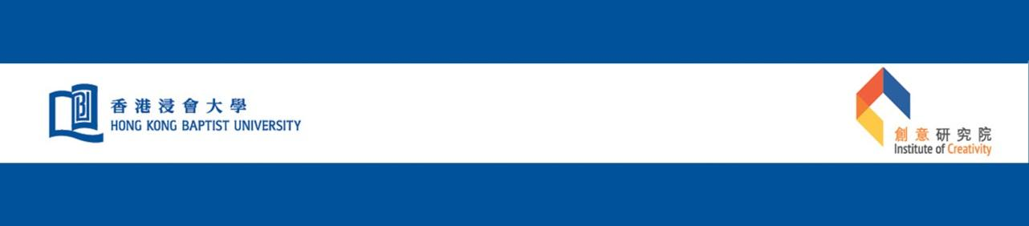
Faculty/School/AVA Logo
(If applicable)

- End -

Updated in September 2021
Annex 1
Hong Kong Baptist University
Institute of Creativity
Application Form for Funding of Events/Activities/Projects
(Funding Limit: $100,000 or Below)

Name/Title of event/activity/project:

Name(s), title(s), Department(s)/School(s)/Academy/Office(s) and contact(s) of applicant(s) (add * to indicate person to contact regarding this proposal):

Objectives in bullet form:

Abstract (if applicable, limited to 1/2 page or 200 words) , comprehensible to a non-specialist:

Main speaker(s)/partner institution(s) (if any) and his/her/its/their background, including web link(s) if available:

Time frame of event/activity/project:

Details (limited to 1 page or 600 words):

Other source(s) of funding applied for. If yes, please specify source(s), and any approved amount(s). If matching funds are requested, attach a copy of the proposal to be matched:

Target audience:

Name of coordinating Faculty/School/Department/Institute/Centre/Office:

Publicity plan :

Estimated budget (please include a cost breakdown) and amount requested from IoC (HK$):

Signature of applicant: _________________ Date: ___________________
Endorsed by:

_______________________________ ____________________ ________________ Name and title (Dean/AVA Director) Signature Date

Endorsed by: _______________________________ Date: ______________________
(Chairman, IoC Management Committee)

Approved by: _______________________________ Date: ______________________
(IoC Budget Controller)
(please use separate sheets if required)

Annex 2
Hong Kong Baptist University
Institute of Creativity

Speaker/Presenter Authorization & Release Form
Re: Scholarly Events Held at HKBU
(Please send the signed form to ioc@hkbu.edu.hk one month before the date of the event)
Date

Dear ______________,

Thank you for agreeing to deliver the below presentations at our University. The Institute of Creativity (IoC) would like to seek your permission to record the presentation and take photographs of speakers, and make them accessible in support of teaching and learning and in promotion of the Institute of Creativity with open access by all regardless of format.

Please note that in granting permission to IoC to record, archive and disseminate the presentation to the community as a whole, you are not giving away the copyright of your presentation to IoC, and that IoC will not use the recording other than the purposes stated in paragraph one above, i.e. in support of teaching and learning and in promotion of the Institute of Creativity. IoC further undertakes not to use the recording for any other activities, commercial or otherwise, without seeking your explicit written approval.

We would appreciate it if you could sign and return to us the form by ____________ (email at ioc@hkbu.edu.hk) to indicate your approval of our request. Should you have any enquiries on this request, please feel free to contact me at (852) 3411 7502.

Yours sincerely,

Liwei Yang

Dr. Yang, Li Wei
IoC Secretary
For and on behalf of IoC

Event Title : ________________________________________________________
Speaker : ___________________________
Organizer : The Institute of Creativity
I, the undersigned, hereby grant the permission to IoC to record the presentation and take photographs of me, and make them accessible in support of teaching and learning and promotion of the Institute of Creativity with open access by all regardless of format.
Name: ______________________ Signature: ____
Date: Email address (optional):

